MANUAL & ASSEMBLY INSTRUCTIONS

PLEASE READ ALL INSTRUCTIONS BEFORE OPERATING THIS APPERATUS.

- TO INCREASE LONGEVITY, PLEASE USE 25LB WEIGHT
- PLEASE USE IN A CONTROLLED SETTING
- DO NOT USE THIS APPERATUS FOR ANYTHING OTHER THAN ITS INTENDED PURPOSE

YOUR ON-POINT ASSEMBLY KIT

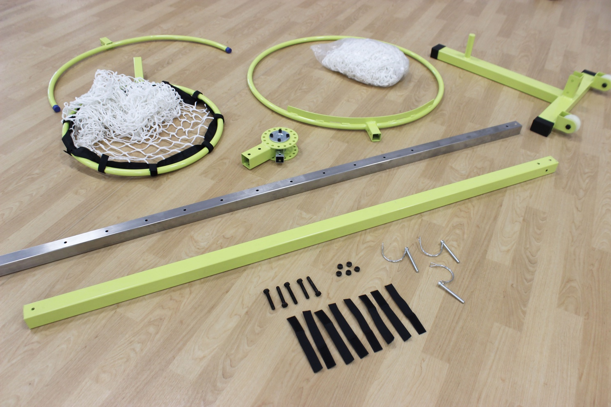

INSTRUCTION MANUAL

Use pictures for important points or important notions

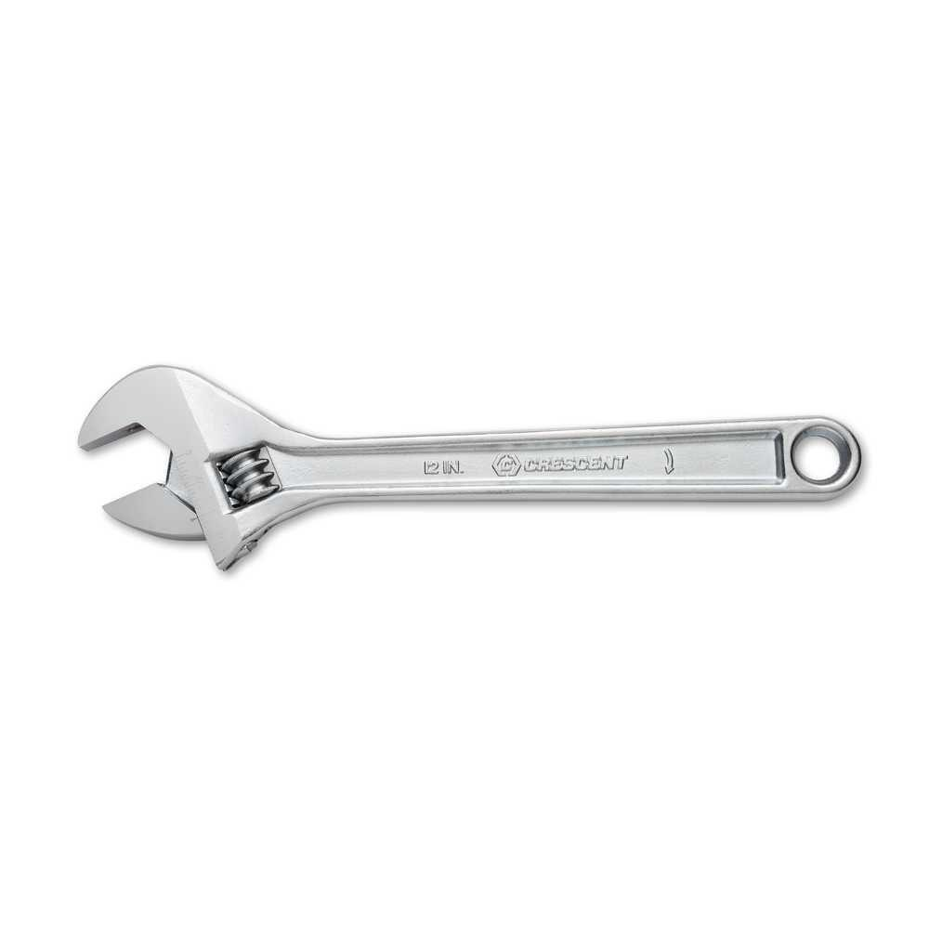NECESSARY ITEM: | - (1) ADJUSTABLE WRENCH NECESSARY FOR ASSEMBLY
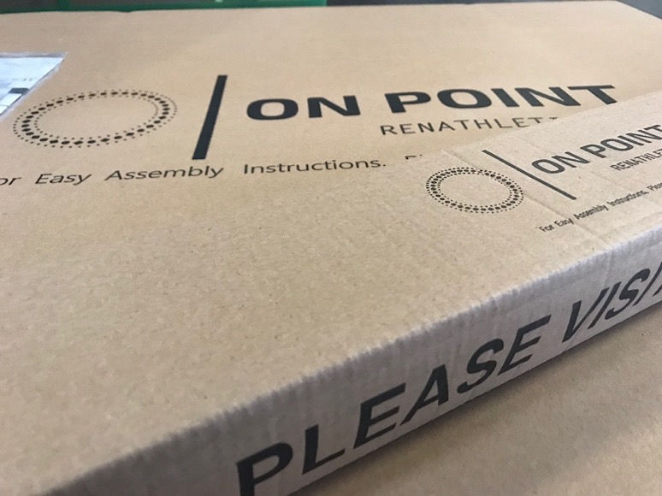 | - (2) ON-POINT VOLLEYBALL BOXES  - 34’’ x 32’’ x 4’’  - 67’’ x 7’’ x 2’’

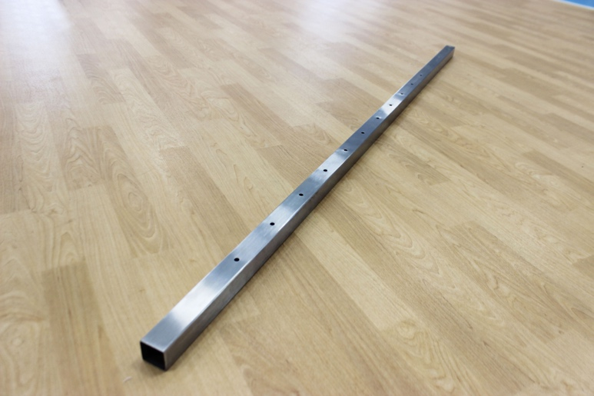 | - (1) VERTICAL INNER POLE (SILVER)
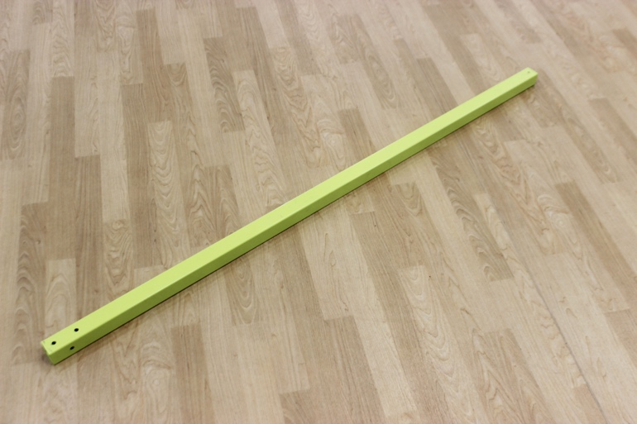 | - (1) VERTICAL OUTER POLE (YELLOW)
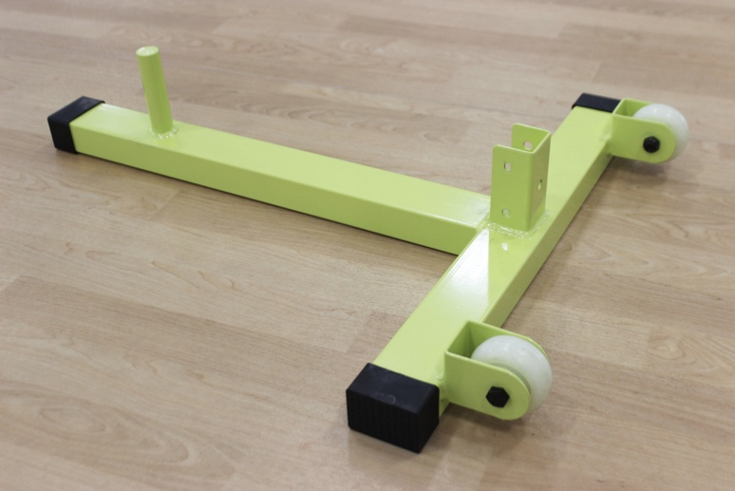 | - (1) BASE
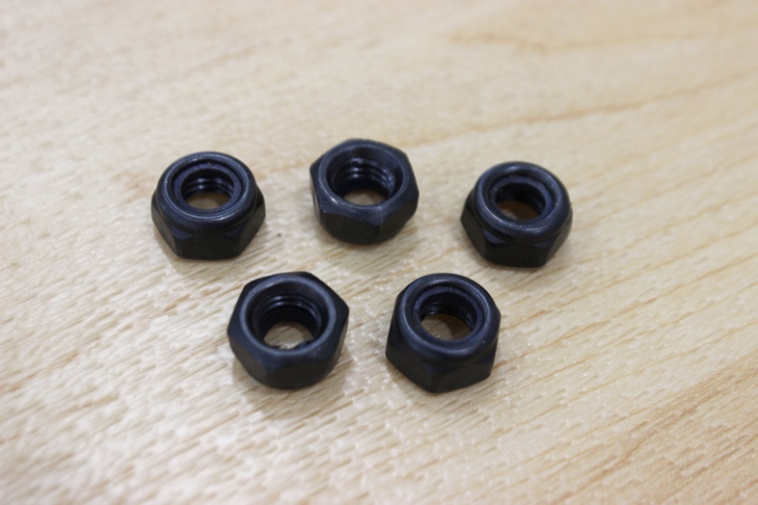 | - (5) NUTS
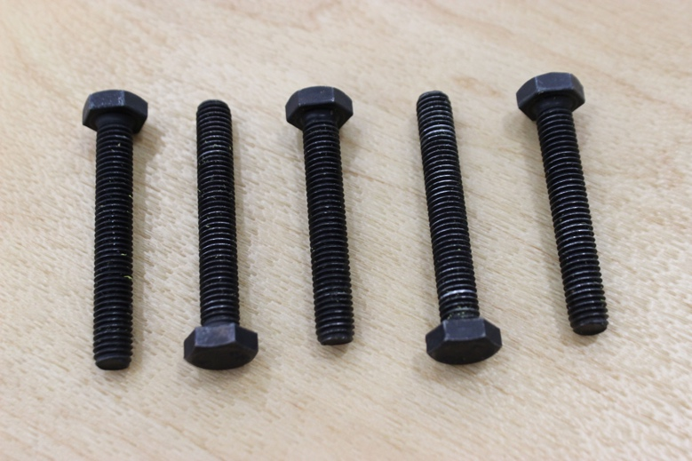 | - (3) 3.5” BOLTS  - (2) 3.2” BOLTS
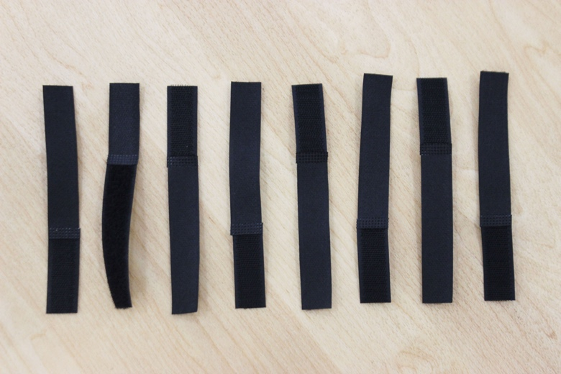 | - (16) VELCRO
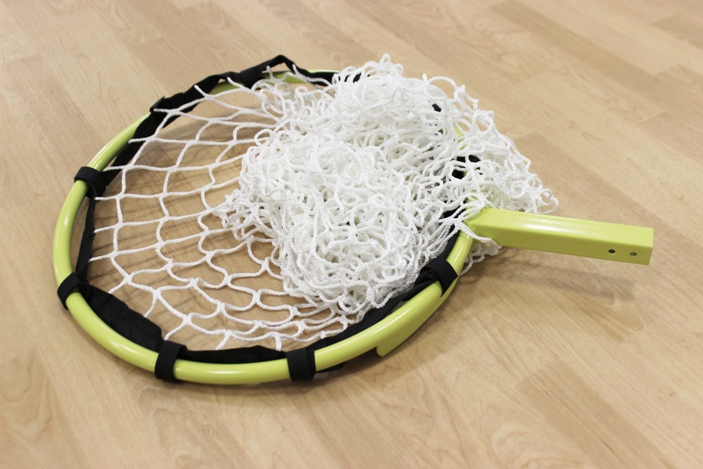 | - (1) 20” HOOP
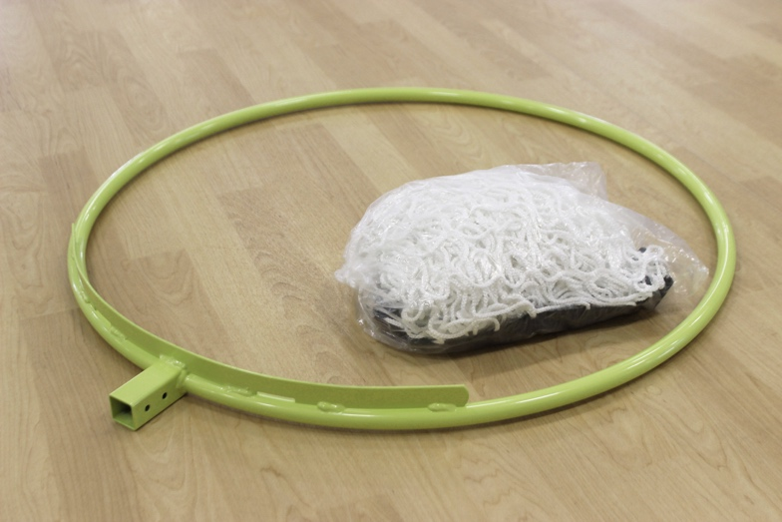 | - (1) 30” HOOP
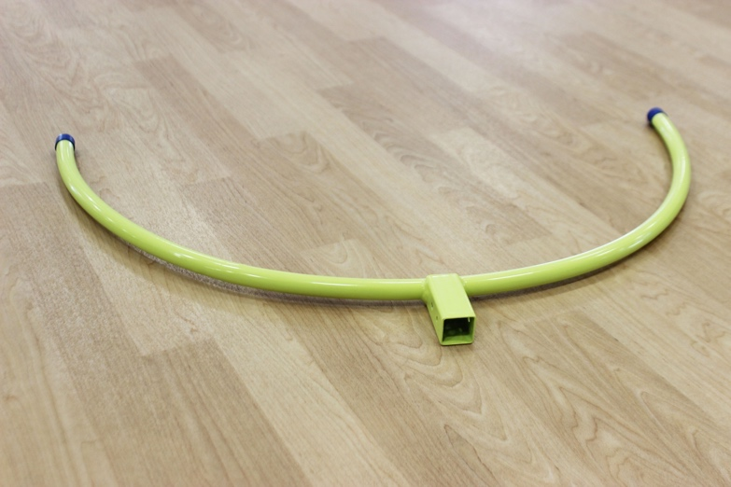 | - (1) TEMPO TARGET HEAD
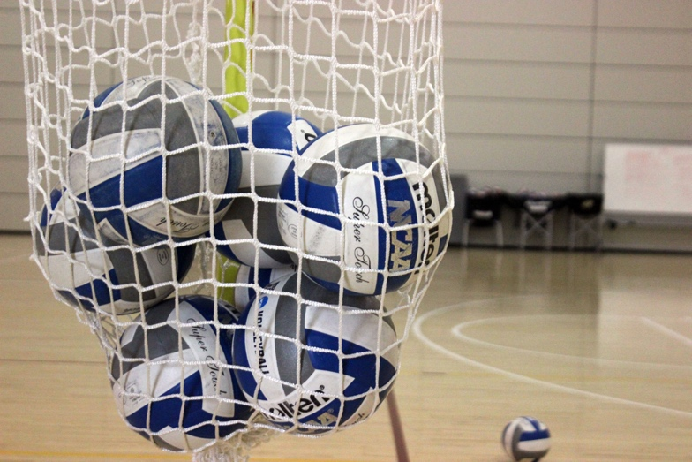 | - (2) NETS
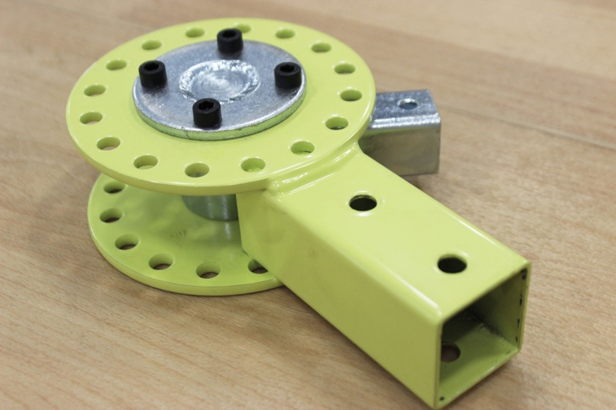 | - (1) ANGLE WHEEL

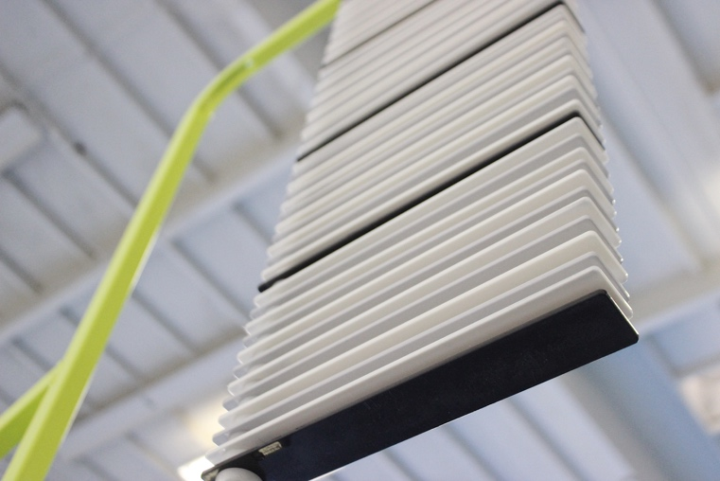 | - (OPTIONAL) TOUCH-POINT ACCESSORY

MANUAL & ASSEMBLY INSTRUCTIONS

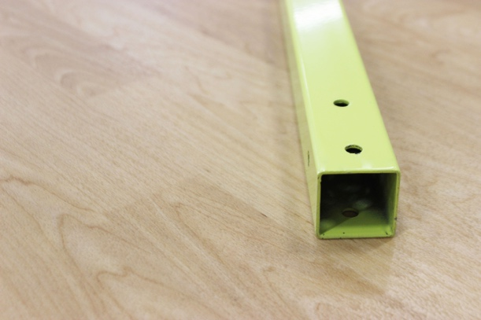
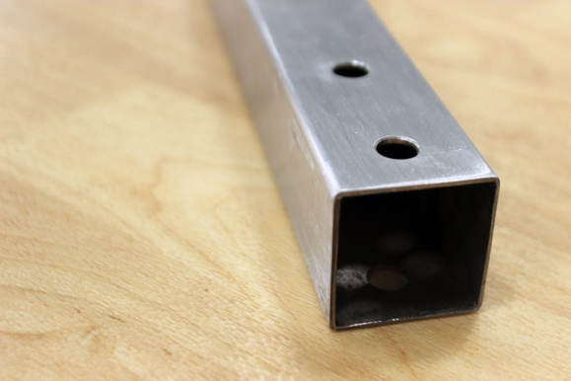

Insert silver inner pre-drilled pole into yellow outer pole

VERTICALLY PLACE ASSEMBLED POLE ON THE BASE

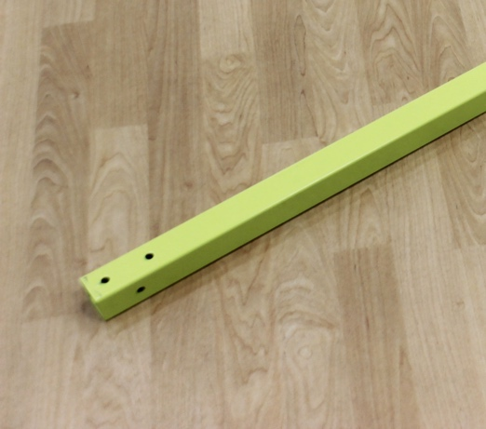
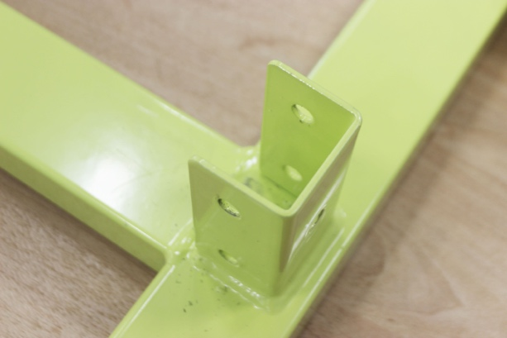

line up outermost pre-drilled hole of the base with outermost pre-drilled hole of the yellow pole
- SECURE POSITION BY SCREWING (3) 3.5” BOLTS AND (3) NUTS THROUGH BASE AND POLES

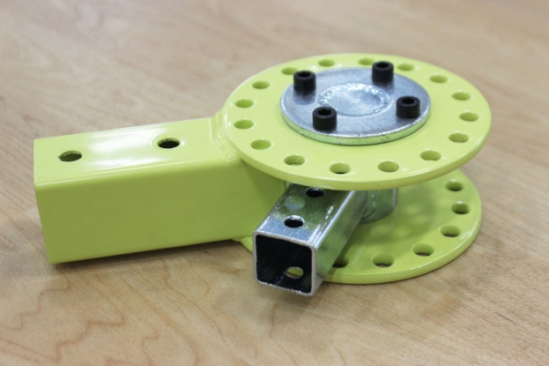
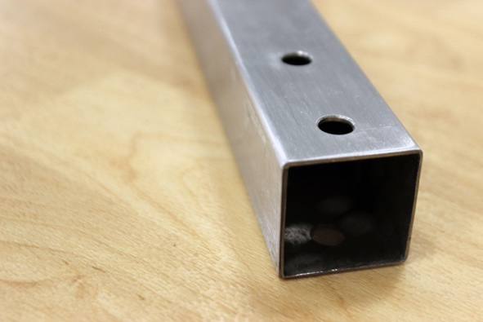

- ATTACH ANGLE WHEEL BY LINING UP SILVER INNER POLE WITH OUTERMOST HEAD OF THE ANGLE WHEEL.

- FASTEN WITH (2) 3.2” BOLTS AND (2) NUTS.

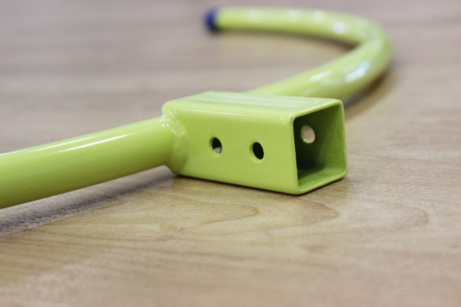
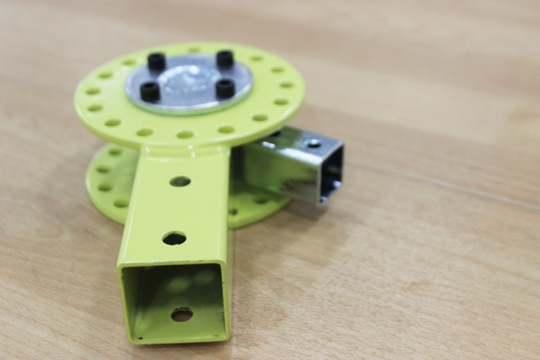

- INSERT THE NECK OF THE ANGLE WHEEL INTO THE TARGET HEAD OF YOUR CHOICE AND

- LINE THE PRE-DRILLED HOLES WITH THE LATCH PIN

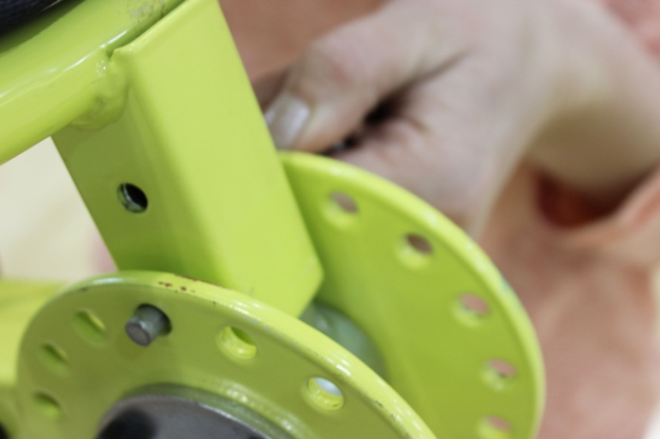

- SET DESIRED ANGLE WITH A LATCH PIN

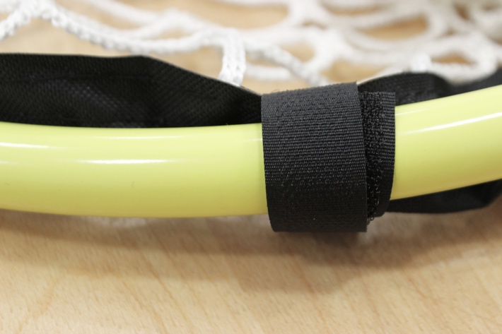

- ATTACH THE NET TO THE RIM OF THE HOOP BY USING 8 VELCRO STRAPS

- CORRECT POSITIONING FOR THE METAL REINFORCEMENT PLATE ON 20” AND 30” TARGETS SHOULD ALWAYS BE FACE DOWN ON THE RIM.

- FOR TOUCH-PONT ACCESSORY ONLY; SET TOUCH-POINT ON THE 7TH HOLE TO REACH 11FT TALL.

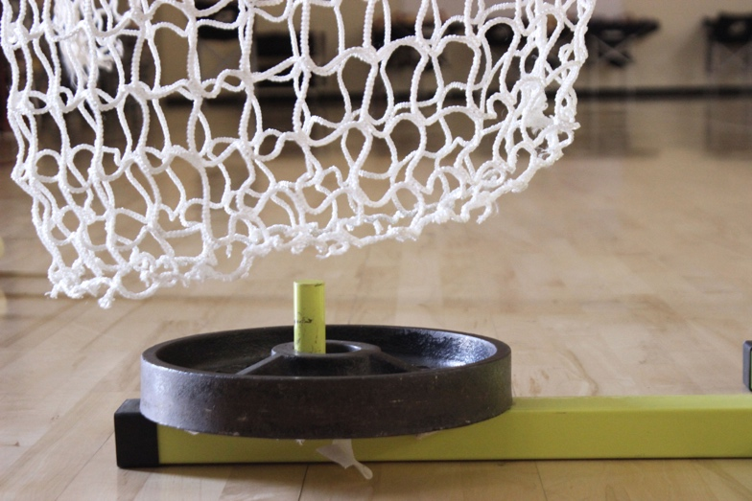

- TO INCREASE LONGEVITY, PLEASE USE 25LB WEIGHT

- PLEASE USE IN A CONTROLLED SETTING

- DO NOT USE THIS APPERATUS FOR ANYTHING OTHER THAN ITS INTENDED PURPOSE

End of document

